DOOR CARD INSTRUCTIONS MANOR PARK BLOCKS A – F
Entering and exiting your room

- Tap your key card (Until the light shows green)
- Turn the lock clockwise twice to open (Located under the handle)
- When you enter, the door will stay unlocked
- To lock the door from the inside – turn the lock under the handle anticlockwise
- Locking your door
- To lock your door, tap your key card to the reader (Until the light flashes Green) – Turn the lock anticlockwise
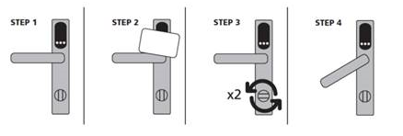

Block A

Ernst Chain Road 07-18 and 35-46
Francis Crick Road 10-12 and 13-15

Block B

Alexander Fleming Road 27-29, 30-35, 36-43 and 60-63
Ernst Chain Road 01-06 and 19-26
James Black Road 11-18, 25-30, 39-46

Block C

Alexander Fleming Road Townhouses 02-05
Alexander Fleming Road 06-17 and 18-20

Block D

Alexander Fleming Road 21-23
James Black Road 47-54 and 63-70
Ronald Ross Road 01-06, 07-20 and 25-32

Block E

Alexander Fleming Road 24-26, 44-51
James Black Road 55-62 and 71-77
Ronald Ross Road 50-57and 66-73

Block F

Alexander Fleming Road 52-59 and 64-66
Ernst Chain Road 27-34 and 47-54
Francis Crick Road 100-107 and 117-124

DOOR CARD INSTRUCTIONS MANOR PARK BLOCKS G, H, P, Q, R and MANOR PARK RECEPTION

Entering and exiting your room

- Tap your key card (Until the light shows green)
- When you enter, the door will automatically lock so it cannot be opened.
from the outside.
- You will still be able to open your door from the inside.
- If you open your door from the inside (e.g. to go to the kitchen) this will
keep the door unlocked.
- Locking your door
- To lock your door, tap your key card to the reader (Until the light shows red)
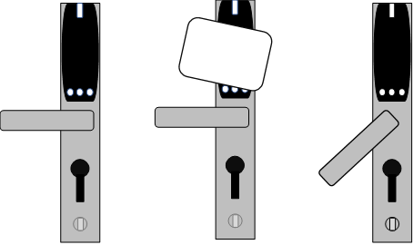

Block G

James Black Road 79-90 and 91-98
Ronald Ross Road 33-40 and 41-47

Block H

James Black Road 99-106 and 107-114
Ronald Ross Road 74-81 and 82-89

Block P

MPP Flats 001-410

Block Q

Daphne Jackson Road 01-17 and 18-33

Block R

Daphne Jackson Road 34-44, 45-56, 57-73, 74-82, 83-91, 92-107, 108-123

Manor Park Reception

MPR Flats 101-121

